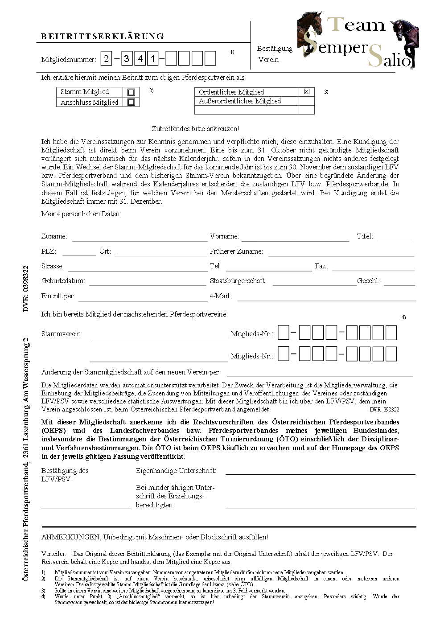

x
x
x
x
x

x

